ERASMUS+ SHORT-TERM STUDENT MOBILITY
(Project number: 2025-1-TR01-KA131-HED-000320753)
Important Dates
Activity | Date
Announcement of Call | 09.08.2026
Beginning of Application | 10.08.2026 / 17.00
Application Deadline | 21.09.2026 / 12:00
*Compulsory Erasmus Language Exam | 23.09.2026 / 10.00
Announcement of Results | 28.09.2026
Waiver and Objection Period | 28.09.2026 - 05.10.2026
Announcement of Final List | 05.10.2026

*Only the students who would like to use their Preparatory School proficiency scores are exempt from the exam. Please notify Erasmus Office by sending mail erasmus@kent.edu.tr.

1- Program Details are detailed as:  · Virtual Kick Off meeting in November 2026  · Academic program and company/institution visits in Düsseldorf, Germany.  · Mobility period: 6–12 December 2026.  · Teaching Language: English  · Format: Blended  · ECTS: 3 ECTS  Number of Scholarships: 8  Individual Support: Students will be supported with 79 Euro for each physical activity day. 2 days for travel and 5 days for activity will reach to a 553 Euro fund for each  Travel support: The travel support for each student is 395 Euro.  For Business, International Trade and Logistics, Political Studies and Public Administration, and International Relations, International Trade and Management, Economics | 2- Program Details are detailed as:  Online and Face to face program details in Innsbruck between 1-18 February 2027  Winter Program - MCI Innsbruck  Number of Scholarships: 4  Individual Support: Students will be supported with 79 Euro for each physical activity day, during 18 days of attendence.  Travel support: The travel support for each student is 309 Euro.  For all bachelor programs

-*-
-*-

Requirements for the candidates:

- Being registered in the Eligible Departments
- -Having a GPA of at least 2.20/4.
- -Having B1 language skills (You will be invited to the exam by Foreign Language School).

Scholarships
Each student will be awarded individual and travel grants, considering the highest score and division (department) diversity.

Students may waive their grant entitlement and participate in the mobility without financial support.

How to apply?
- 1- For online application, please go to "erasmusbasvuru.ua.gov.tr". By logging in with your e-government account information, you can see our active call for Short Term Program.
- 2- If you have additional score-earning documents from the table below, please upload them. Another way, we can not be aware of it and count.
- 3- If you have difficulty during your application, please ask to us: erasmus@kent.edu.tr

EVALUATION PROCESS AND THE ANNOUNCEMENT OF THE GRANTED STUDENTS
Erasmus student selection and grant allocation are carried out by ranking eligible applicants from the highest to the lowest score, based on the evaluation criteria and weighted scores announced by the National Agency. The distribution of grants also takes into account the diversity of academic departments. The selection results are announced through the application system and our website. The relevant criteria are outlined below:

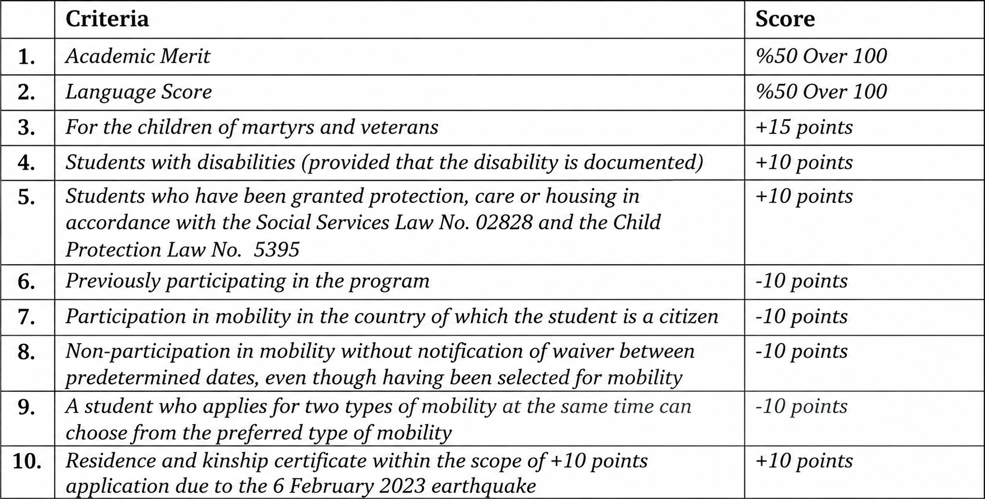

Details of Criteria and Application Documents (numbers are related the table above)
1.Your GPA is retrieved from e-Devlet by the application system.
2. Language Exam
An English language exam will be organized for all the applicants. All the applicants are obliged to attend the exam. Only the ones who have;
- a valid language exam score by Istanbul Kent University Foreign Language School
- at least 86 over 120 from TOEFL are exempt from this obligation (upload your score).

If you don’t have any of these, you should attend to language exam which will be held at School of Foreign Languages at Taksim. The examination venue details will be sent to all applicants via their institutional email addresses after the application period closes on 21 September.

3. For the children of martyrs and veterans
Please upload your scanned card to the application system so that +15 score will be applied when calculating your final score.
4. For disabled students
Please upload your report about your disability that +10 score will be applied when calculating your final score.
5. Please upload your document that +10 score will be applied when calculating your final score.
6. Previous participation causes -10 points.
7. If you are going to go to the country of your origin, this causes -10 points.
8. Please indicate during application.
9. Please indicate during application.
10. Please indicate during application.

Green Travel
Students who choose environmentally friendly means of transportation for their journey will be eligible to receive Green Travel Support under the Erasmus+ Programme. Students who choose green travel (low-emission means of transport) will be paid €535 instead of the standard travel support of €395.

Additional Grant Support for Student and Recent Graduate Mobility
Additional Grant Support may be provided to participants with fewer opportunities in addition to the Erasmus grant to which they are entitled. To be eligible for this additional grant, participants must be considered individuals with fewer opportunities due to economic and/or social disadvantages and fall into one of the following categories:
- Participants who are subject to the provisions of Law No. 2828, including those for whom a protection, care or accommodation decision has been issued by the Ministry of Family and Social Services under Law No. 2828.
- Students for whom a protection, care or accommodation decision has been issued under the Child Protection Law No. 5395.
- Students receiving an orphan's or survivor's pension.
- Martyrs' and veterans' spouses and children, and veterans themselves.
- Students who can provide official documentation proving that they, their family, or their legal guardian receive financial assistance from a public institution (such as municipalities, ministries, Social Assistance and Solidarity Foundations, the General Directorate of Foundations, the Turkish Red Crescent, or AFAD) at the time of application.
- Students with disabilities.
- Students whose parent or legal guardian receives a disability or needy pension under Law No. 2022, dated 1 July 1976, on pensions for needy, disabled, and elderly Turkish citizens.
- Students who themselves, or whose first-degree relatives, have received disaster assistance from AFAD.

For more information, you can send an e-mail to erasmus@kent.edu.tr.

